Assignment 33.
- What is variant? How to create variant, Explain it?
- A Variant is a saved set of input values for a report selection screen.
- It lets us save parameter/select-option values so you don’t need to enter them every time you run the report.
- Steps to create Varient:
- Step 1: enter FKART name -> click on save icon.
- 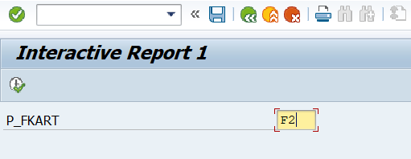
- Step 2: Enter Variant name description click on save.
- 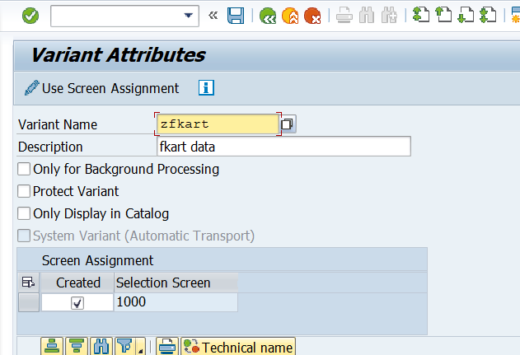
- Step 3: click on this to get saved data.
- 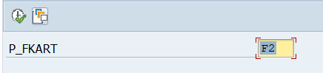
- Step 4: select the saved variant and enter.
- 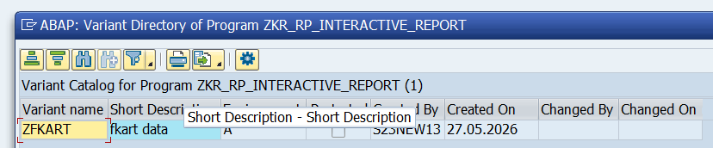
- To check the variants -> GoTo -> variants ->get.

- What is Modularization techniques and Types of it?
- Modularization means breaking a large ABAP program into smaller reusable blocks/modules.
- Instead of writing everything in one place, we divide the code into manageable pieces.
- Used for:
- better readability
- code reuse
- easy debugging
- easy maintenance
- avoids duplicate code
- Types:
- 1.Include
- 2.Subroutines
- 3.Function Modules
- 4.Macros
- 1. Include: Include is used to split a large ABAP program into multiple smaller programs/files.
- Used to declare variables, divides large programs.
- Syntax:
- INCLUDE ztop.(name shouldstarts with Z..).
- Keyword: INCLUDE Z---.
- 2.Subroutines: Subroutine is a reusable block of code written inside FORM ….. ENDFORM.
- Called using PERFORM. (Keyword = PERFORM).
- Use: reusable logic inside same program.
- Syntax: FORM display_data.
- WRITE 'Hello'.
- ENDFORM.
- PERFORM display_data.
- 3.Function Module:- Function module is a reusable procedure created in SE37
- Can be called from multiple programs. reusable globally.
- Syntax:
- CALL FUNCTION 'ZKR_FM'.
- 4.Macros:- Macro is used to write reusable code using:
- DEFINE ... END-OF-DEFINITION.
- Syntax:
- DEFINE disp.
- WRITE : / &1.
- END-OF-DEFINITION.
- disp 'Hello'.
- Use:
- avoid repeating small code snippets
- shorthand reusable logic

- What is syntax of include and create one include and use it in program?
- Syntax : INCLUDE <include_program_name>.
- Step 1: Create Main Program.
- Ex:ZKR_RP_MODULARIZATION.
- Step 2: Create Include Program (inside main program)
- INCLUDE zdata_declare
- Double click on zdata_declare.
- Asks: Create include? ->yes
- Now include is created.
- It is used to insert the code of one ABAP program into another program. It helps split large programs into smaller reusable parts like global declarations, selection screens, and subroutines. Example: INCLUDE zdata_declare. where zdata_declare contains global data declarations used in the main program.
- INCLUDE is not executable program.
- Example:
- 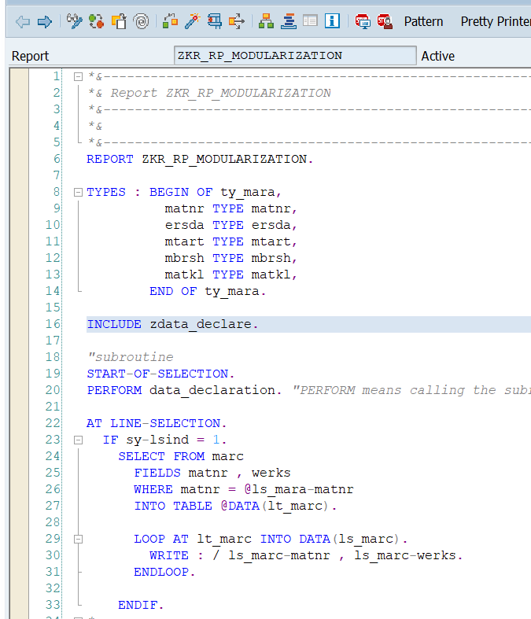
- After double clicking on INCLUDE:-
- 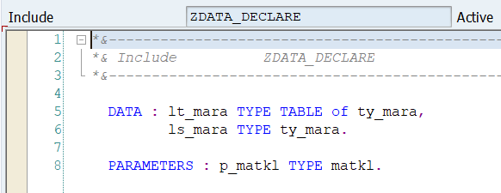

- Can we use includes in FM?
- Yes, we can use INCLUDE inside a Function Group / Function Module.
- But usually the include is added in the Function Group, and the Function Module uses it through that function group.
- Yes, includes can be used with Function Modules. Function Modules belong to a Function Group, and that Function Group is internally divided into multiple include programs like TOP include for global data and UXX include for function module implementations. These includes are used to organize the code and declarations of the function group.
- What is subroutine and use of it?
- A Subroutine is a reusable block of code in ABAP written using
- FORM … ENDFORM.
- And called using PERFORM.
- USE:-
- It is used to execute the same logic whenever needed without rewriting the code.
- Write once → call many times.
- Code reusability.
- Avoiding duplicate code.
- Better readability.
- Easy debugging and
- Easy maintainance.

- Real-Time Example:
- Suppose report has:
- fetch MARA data
- display MARA data
- Instead of writing all in one place:
Main program:
- START-OF-SELECTION.
PERFORM fetch_data.
PERFORM display_data.
Subroutine:
FORM fetch_data.
SELECT *
FROM mara
INTO TABLE @DATA(lt_mara)
UP TO 10 ROWS.
ENDFORM.
FORM display_data.
LOOP AT lt_mara INTO DATA(ls_mara).
WRITE : / ls_mara-matnr.
ENDLOOP.
ENDFORM.
- What are the key word used in subroutine?
- FORM: Used to define/create the subroutine.
- PERFORM: Used to call/execute the subroutine.
- USING: Used to pass input values to subroutine.
- CHANGING: Used when subroutine needs to modify and return the value.
- TABLES: Used to pass internal tables to subroutine.(it is a old syntax).
- ENDFORM: Marks the end of the subroutine.

- Create one subroutine example in program using mara to fetch the data?

TYPES : BEGIN OF ty_mara,
matnr TYPE mara-matnr,
ersda TYPE mara-ersda,
mtart TYPE mara-mtart,
END OF ty_mara.
DATA : lt_mara TYPE TABLE OF ty_mara,
ls_mara TYPE ty_mara.

START-OF-SELECTION.
PERFORM fetch_data.
PERFORM display_data.
*---------------------------------------------------------------------*
* Fetch Data from MARA
*---------------------------------------------------------------------*
FORM fetch_data.
SELECT matnr
ersda
mtart
FROM mara
INTO TABLE lt_mara
UP TO 10 ROWS.
ENDFORM.
*---------------------------------------------------------------------*
* Display Data
*---------------------------------------------------------------------*
FORM display_data.
LOOP AT lt_mara INTO ls_mara.
WRITE : / ls_mara-matnr,
25 ls_mara-ersda,
45 ls_mara-mtart.
ENDLOOP.
ENDFORM.

- After Endform can we access write statement. if yes how if no why?
- YES.
- Using START-OF-SELECTION.
- After ENDFORM, we should not directly write executable statements like WRITE outside the processing blocks. It give error like “statement not accessible” because it is outside the report event flow. To execute WRITE after ENDFORM, we should place it inside an event block like START-OF-SELECTION or END-OF-SELECTION.

